Introducing the New Joomla 4 Administrator Template
Written by Valentín García
Category: Joomla News
Published: 06 August 2018
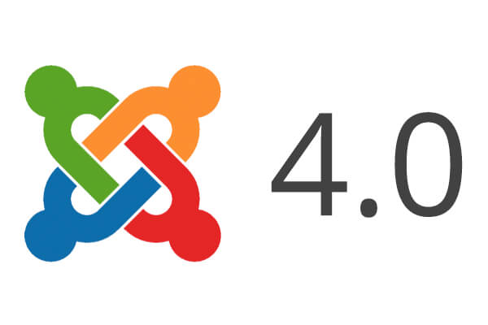
A few months ago, we wrote about the proposed design for the Joomla 4 administrator template.
The Joomla team is now making progress in turning that design into code.
In this post, I'll show you the current state of the Joomla 4 admin template, which is called Atum. Keep in mind that the current version is Alpha 4, which means we don't even have a Beta version available yet. A lot will change before the final release.
This image below shows the login page for the admin area:
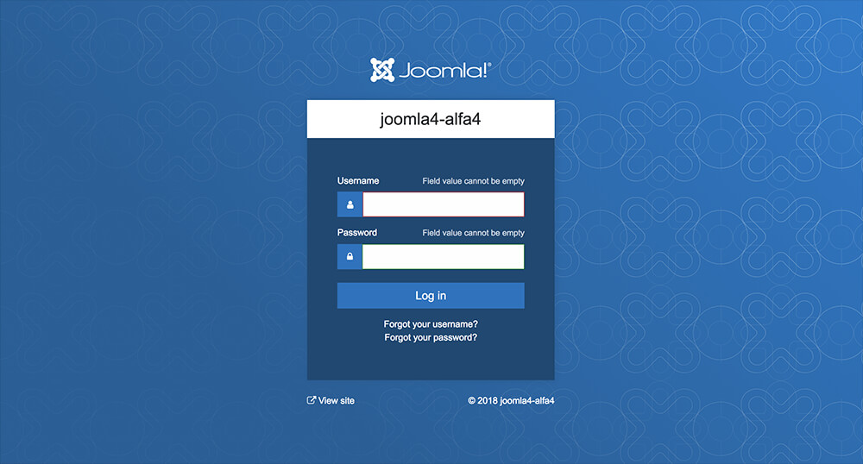
Looks and feels beautiful, doesn't it?
The admin menu is now on the left-side of the screen. Once you're logged in, you can expand or contract the menu using the "Toggle Menu" feature. If you navigate to other areas of the site, the menu respects your decision by staying expanded or contracted.
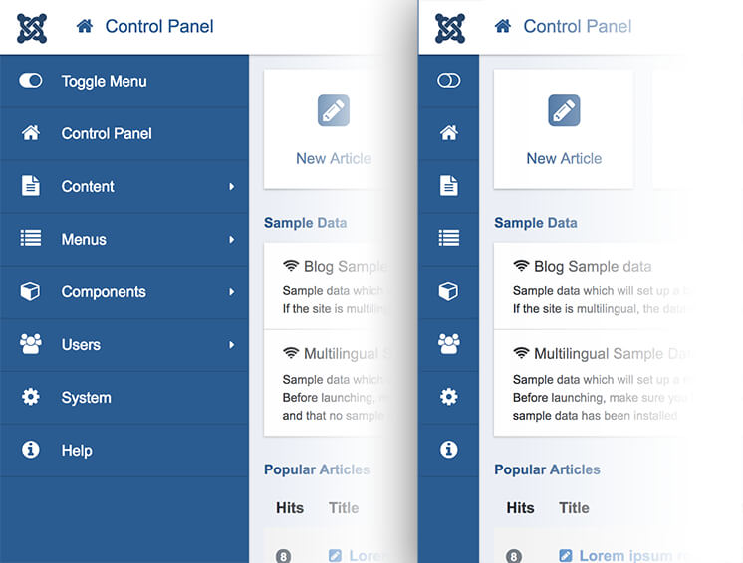
Besides design improvements, the lastest release (Alpha 4) also introduced important changes in the admin menu structure. Here are a few examples of those changes:
- Modules are now managed through the "Content" submenu.
- The "System" menu doesn't have a submenu anymore.
- In the "System Panel" page, you have quick access to all the key areas, including "Extensions", "Access", Global Configuation" and more.
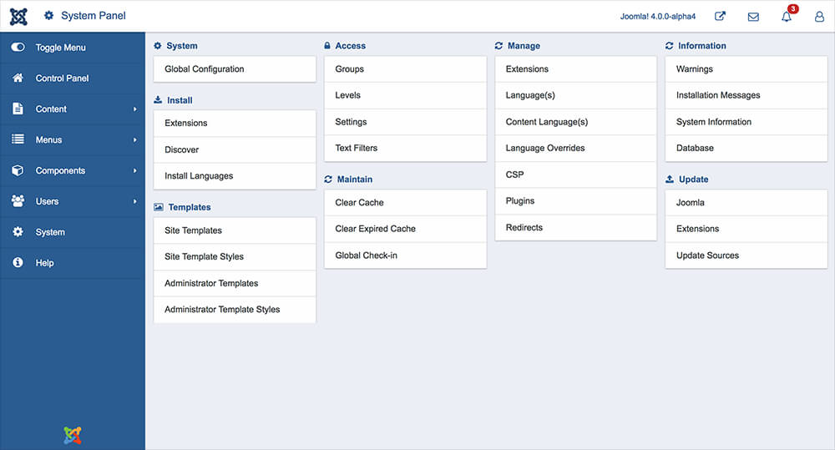
The "Articles" management page is more colorful now. I am sure many administrators will find it fun to work with. In my opinion, the current verion does look a bit busy. This is one of the screens that still needs more work.
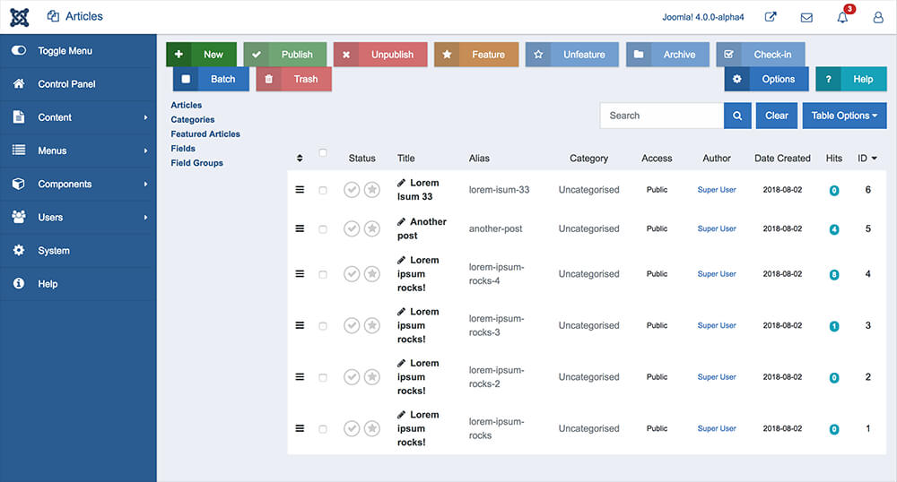
The article edit screen looks clean and concise. This screen is also a work in progress.
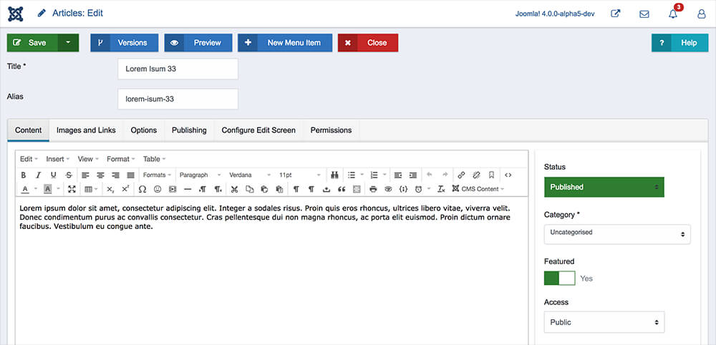

Additional Reading for Joomla 4
- A First Look at Joomla 4
- The New Joomla 4 Media Features
- Introducing the New Joomla 4 Installer
- A New User Interface for the Joomla Backend

Summary
Overall, the current Joomla 4 design progress looks promising and very encouraging.
We're sure that the final administrator panel will look and feel as great as the original proposal.
We invite you to download the latest Joomla 4 Alpha version and test the new design and features. If you catch any bugs, please report them via Github.

